Name: Asim Nath Pant 
Student ID: 24071188
Program: BSc (Hons) Computing L3
Section: A
Module: Fundamentals of Data Science
Title: Bi-weekly Assignment: Assignment 1 (Week 1 & 2)

PART 1:

Translate the following statements into Python expressions in IDLE:

- The perimeter of a rectangle with length 9 & width 6.

- Output:

- Python is great, it’s wild!

- Output:

- 2 to the 10th power

- Output:

- 7 factorial minus 5 factorial

- Output:

- Your forename multiplied by 5

- Output:

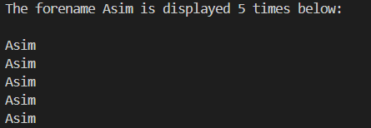

- Your name left justified 15 spaces

- Output:



- PI to 5 decimal places

- Output:

8. 200 modulus 12

- Output:

9. 7.2 as an integer value

- Output:

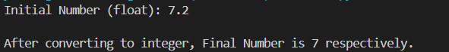

10. The Unicode encoding for your name

- Output:

PART 2:

- Write a program to take a number input from the user and display whether the number is even or odd.

- Output:

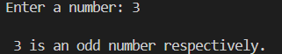

- Write a program that prompts the user for two integer values and displays the results of the first number divided by the second, with exactly two decimal places displayed.

- Output:

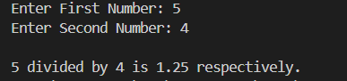

- Write a program that will convert Celsius value to Fahrenheit.

- Output:

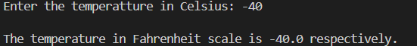

- Write a program to find the Euclidean distance between two coordinates. Take both the coordinates from the user as input.

- Output:

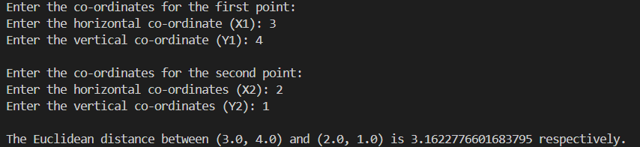

- Write a program to find the simple interest when the value of principle, rate of interest and time period is provided by the user.

- Output:

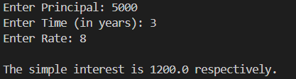

- Write a Python program to find those numbers which are divisible by 7 and multiple of 5, between 1500 and 2000 (both included).

- Output:

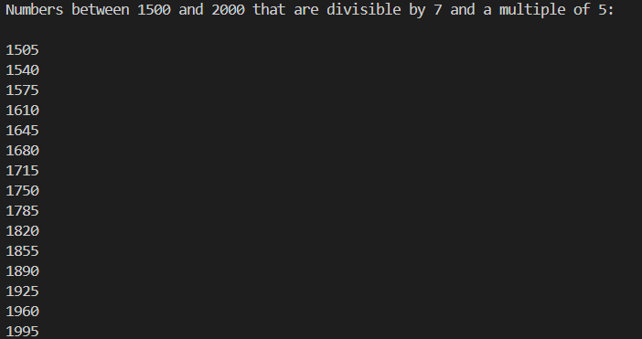

- Write a Python program that accepts a string and calculates the number of digits and letters.

- Output:

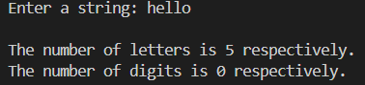

8. Write a program to create a number guessing game for the user. The program should ask the user to input a number. The program specifications are as mentioned below.
- The program should generate a random number for the answer.[2.5]
- The program should prompt the user for a number input.[2.5]
- The program should provide the feedback to the user after each guesses (e.g. “Too high”, “Too low” or “Correct number”).[2.5]
- The program should check the user input for 5 times and allow the users to guess for at most 5 times if their input don’t match the answer number.[2.5]
If the user is not able to guess the answer within 5 times, the program should display “Game Over” message and exit.

- Output:

